Project Title: Simple Fire Alarm Circuit.

Semester Project: Digital Logic Design

Course: BSCS-B

Teacher:

Ma’am Warda.

Submitted by:

Vanya Ahmed Siddiqui (200901095)

Namrah Waseem (200901035)

Zooia Zainab (200901034)

Abstract

The use of fire Alarm System for Security has become a necessity in every office and in every work field. So, we thought of creating a fire alarms system but this time by using an IC. As we were learning about ICs in our Digital Logic Design lab so we thought why don’t we do a research about it. We searched that (can fire alarms systems be made using an IC?) and we started working on it.

In our project we have used a 10K thermistor(NTC). This is the main component of our project and its purpose is that when the temperature increases/rises the resistance of this thermistor decreases (the working of NTC thermistor). We have used a potentiometer of 10Kohm and it purpose is to divide the voltage output. When the temperature increases its (thermistor) resistance decreases the output of the voltage divider (POT) will increase and its output will be given to LM358s (IC) non-inverting input (pin 2). As the LM358 is a dual operational amplifier it would operate in a comparator mode in this project. The input signals will be applied to the inverting terminals and on the other hand non-inverting terminals will be compared to produce output. The output of non-inverting terminals will be high. So the operational amplifier will become high and the buzzer will make a sound. In our simulation we have attached an LED too so that we would know that when the buzzer will make a sound the LED would turn on and vice versa.

Figure 1: Block Diagram 2

Figure 2: Detailed Circuit Diagram 2

Figure 3: Truth Table for My Design Combinational Part 3

# Contents

Chapter 1: Introduction 1

1. Overview of Project 1
2. Block Diagram of Complete System (without using ICs, just use simple blocks) 2
3. Clear Work Division 2

Chapter 2: Design 3

1. Problem Statement 3
2. Truth Table / State Diagram 3
3. Complete Logic Diagram 6
4. Simulation Results 7
5. Schematic Diagram 9
6. Details of ICs used 9
   * LM358 9
7. Details of Other Components used like diodes, transistors, resistors etc. 10

Chapter 3: Project Applications /Further Suggestions (Optional) 11

Chapter 4: Future Recommendations 12

References / Bibliography 13

# Chapter 1: Introduction

### Overview of Project

Our project is about detecting a fire as mentioned in the Name **Fire Alarm system.** We have used a **10k NTC thermistor** which is the main component of our system. A **4.7Kohm resistor**. A **Potentiometer of 10Kohm** which will act as a voltage divider. A **LM358** which is **dual operational amplifier** and its input signals will be applied to inverting terminals whereas the non-inverting terminals will be compared to generate an output. The output of Potentiometer is connected with the non-inverting inputs of the IC LM358. From (**pin number 2**). **Pin 3** is used to divide the resistor and thermistor, **pin 8 as VCC** and **pin 4 as GROUND.** **Pin 1** is used as an output which is connected to the one input to the buzzer the other input of the buzzer is connected to GROUND. And according to the rise in temperature the buzzer will make a sound e.g. in case of smoke and fire it would detect it and make a sound.

**INPUT:**

In input we can say that an input can be the temperature. E.G. (26C), (77C) and

(10C).

**PROCESS:**

Whenever the temperature will increase for e.g (77C) the resistance of the

thermistor would decrease. The decrease in thermistor would automatically

increase the output of the potential divider. As the output of the potential divider

is connected with the non-inverting terminal of the operational amplifier. Its

value will become more than the inverting inputs. So as a result the output of

operational amplifier or LM358 will become high and as a result it would

generate the buzzer to make a sound.

**OUTPUT:**

According to the value of temperature our output will be generated depending

upon the output of the potential divider. If the temperature will be high the

output of POT will be increased resulting in the Buzzer to be activated when

compared by the non-inverting terminals of the IC (if its value will be more than

the inverting inputs). if the temperature would decrease the output of POT

will decrease too resulting in the buzzer not to be activated when compared by

the non-inverting terminals of the IC (if its value will be less than the inverting

inputs).

### Block Diagram of Complete System (without using ICs, just use simple blocks)

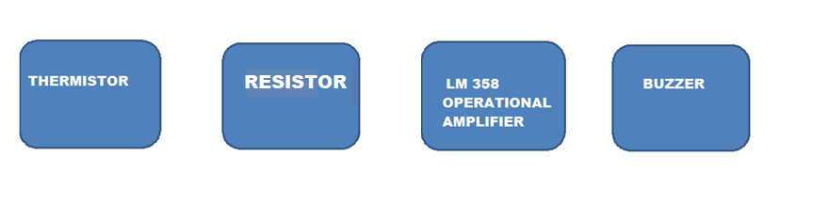

**Figure 1: Block Diagram**

### 1. Clear Work Division

**WORK DIVISION:**

* First of we all (vanya,namrah and zooia) will be working on the logic diagram together a we all will perform the stimulation on the multisim software.
* Vanya will be guiding and observing the circuit on multisim whether it will work or not. While zooia will be making the circuit on multisim with a liitle help from vanya according to the logic diagram and in the end namrah will run the circuit and verify it with the truth table.
* After that vanya will practicaly implement the circuit in hardware with a little help and guidence from namrah. zooia will observe the hardware and guide us and she will be involved in the hardware too.
* Then after that we (zooia,vanya and namrah) would write the project report which will contain every detail of our project according to the task we have performed together.

**Figure 2: Work Division**

# Chapter 2: Design

### Problem Statement

there are many cases in which a fire alarm system needs to be installed.so we have designed a fire alarm system which must be able to detect fires at all locations so that in case of any fire emergency it should activate and alert the owners of the house or a specific building, that a fire has been broke out. this system would reduce the cost of fire-insurance protection and would provide safety for the homeowners.

### Truth Table / State Diagram

**TABLE RELATED TO CALCULATIONS:**

|  |  |  |  |
| --- | --- | --- | --- |
| TEMPERATURE | RESISTIVITY OF NTC THERMISTOR | %AGE  OF RESITIVITY | OUTPUT  OF  BUZZER |
| 26C (Room Temp) | Normal/null | 50% | OFF |
| 55 (High) | Decrease | 30% -0% | ON |
| 77 (High) | Decrease | 31%-0% | ON |
| 19 (Low) | Increase | 50%-100% | OFF |
| 10 (Low) | Increase | 50%-100% | OFF |

**Figure 3: Truth Table for My Design Combinational Part**

### 2.3 Complete Logic Diagram

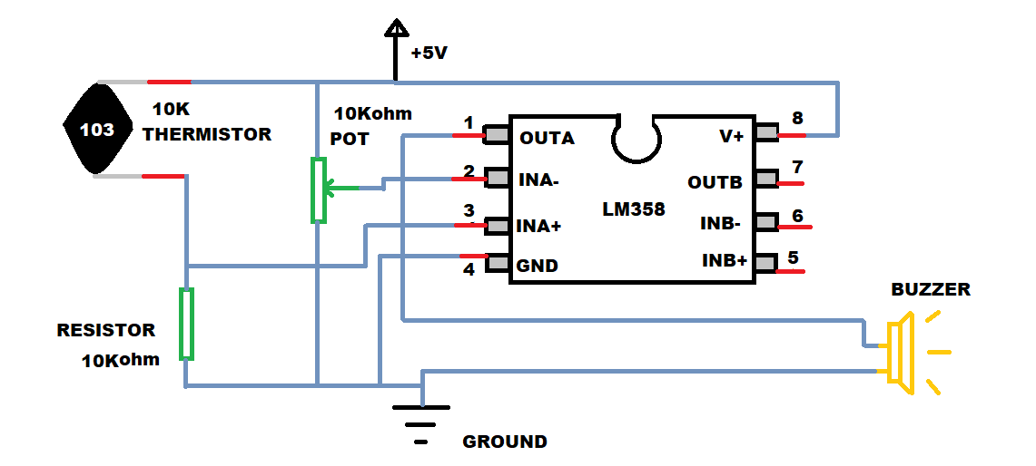

### Simulation

.

* if temperature is normal e.g (26C) room temperature the buzzer will not make a sound we have connected a LED so that when LED will light up it means the buzzer has made a sound.

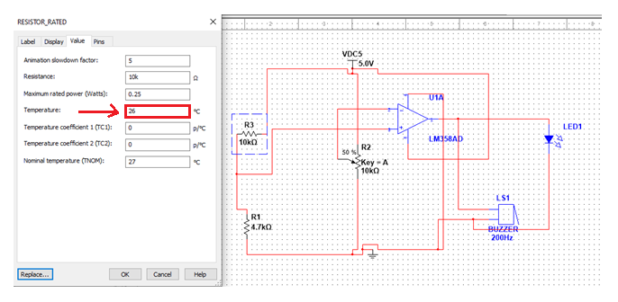

* after result.

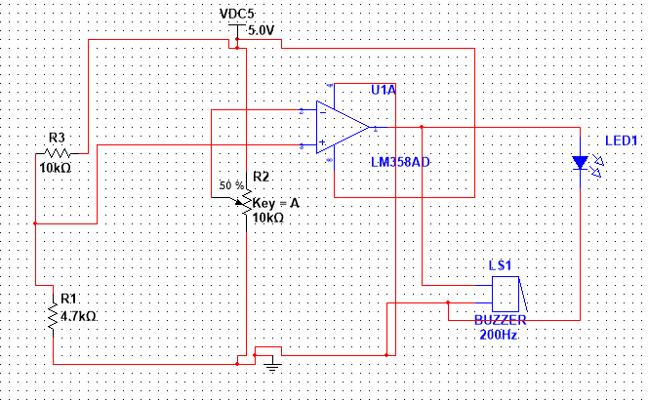

* Temperature set to (55C) the resistivity will be decreased as temperature will decrease.

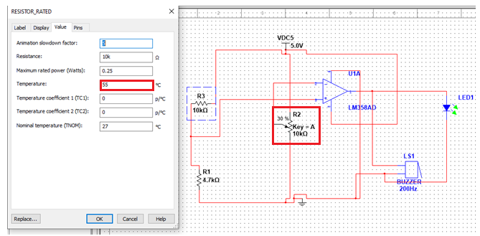

* Result: buzzer will make a sound.

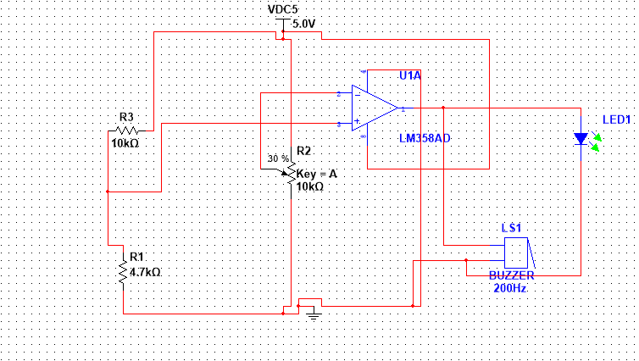

* If the temperature will decrease (10C) the resistivity will increase.

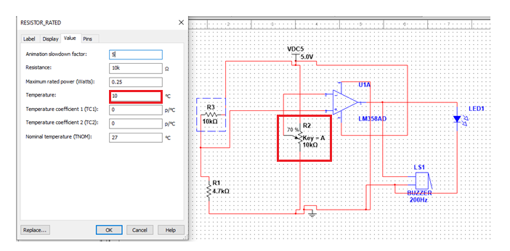

* 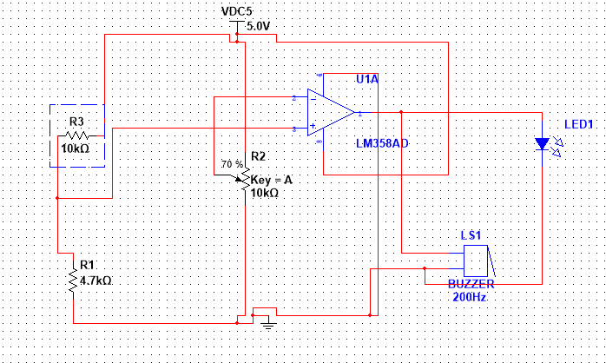Result: the buzzer will not make a sound.

### Detailed Schematic of Design and its Description

* **Detailed Table:**

|  |  |  |  |
| --- | --- | --- | --- |
| Serial No# | Component Used | IC No# | Quantity |
| 1 | NTC Thermistor 1Kohm. | - | 1 |
| 2 | Potentiometer (voltage divider). | - | 1 |
| 3 | Resistor 4.7Kohm. | - | 1 |
| 4 | Operational Amplifier | LM358 | 1 |
| 5 | Buzzer | - | 1 |
| 6 | VCC 5V | - | 1 |

### Details of ICs used

* + 1. **IC Number**

**LM358**

#### Function Table

|  |  |  |
| --- | --- | --- |
| PIN NUMBER | PIN NAME | PIN FUNCTION |
| 1 | Output A | Output of OPAM A |
| 2 | Inverting Input A | Inverting Input of OPAM B |
| 3 | Non-Inverting Input A | Non-Inverting Input of OPAM A |
| 4 | Ground | Ground |
| 5 | Non-Inverting Input B | Non-Inverting Input of OPAM B |
| 6 | Inverting Input B | Inverting Input of OPAM B |
| 7 | Output B | Output of OPAM B |
| 8 | VCC | Supply Voltage |

#### Schematic

.

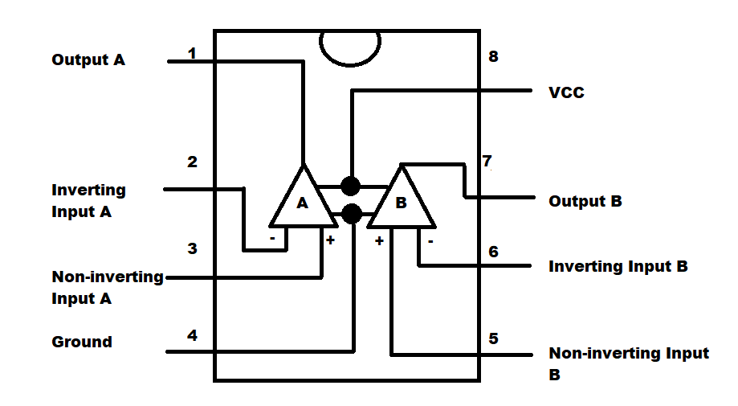

### Details of Other Components used like diodes, transistors, resistors etc.

* **LED**

**SCHEMETIC:**

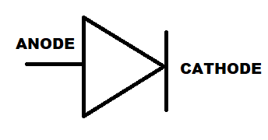

**.........................................................................................................................................**

* **RESITOR**

**SCHEMETIC:**

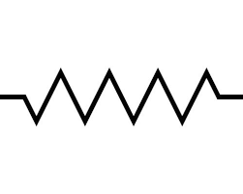

**………………………………………………………………………………………..**

* **THERMISTOR**

**SCHEMETIC**:

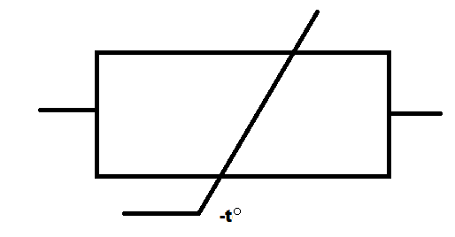

**……………………………………………………………………………………………**

* **POTENTIOMETER**

**SCHEMETIC:**

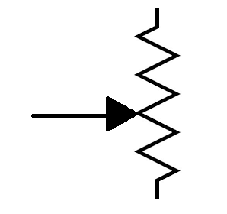

**............................................................................................................................................**

# Chapter 3: Project Applications

* **OFFICES:**

As in an office you have to fully work on a computer. In some cases, a wire can get loose or in other hand your switch board/ plug may be overloaded. So in both the cases fire may broke out and will cause destruction. so in that case a fire alarm detector must be installed so that all the members of that office would know a fire has been broke out so that their life may be saved.

* **RESTAURANTS:**

Most of the reason for the cause of fire in restaurants are the faulty plugging of AC and other ventilations. They are 9% responsible for the cause of fires. The other reasons include those customers who smoke cigarettes or any other thing similar to cigarette. These results might cause fire in a restaurant so, a fire alarm system must be installed for the security of people.

* **MOVIE THEATER:**

As it also depends upon heavily electrical equipment’s so, a malfunction in a projection might cause a spark and if something like paper or any other thing that can cause fire is nearby. It may catch fire and cause harm. So that is why a fire alarm detector must be installed for the security of people.

# Chapter 4: Future Recommendations

* Now days fire security alarms/system usage has been spreading rapidly around the world. Before it was not considered important but, today people around the world consider it as an essential source for their safety of life. As the technology is advancing so its sources too. If we talk about fire alarms the fire alarms of the future should have the capability of providing better information to fire departments and other occupants. With these developing technology fire alarm combining with other equipment’s like, mass notification and security will help to reduce cost and would also help for better life safety for people through technology.
* These alarms will help to change the style/nature of the buildings as they will integrate with the building automation system which will provide protection for the urban buildings so that it may be suitable for both the residential and commercial buildings.
* The future fire alarms will be software based this would help the supplier as well as it would reduce the cost too. The important thing is that as they will also be connected to internet so that the firefighters should get a live feed. Whenever there will be a fire threat they would get a live photages due to which they would be more prepared to act effectively and safely to save the lives of people.

# References / Bibliography

* <https://circuits-diy.com/simple-fire-alarm-circuit-using-lm358/>.
* <https://www.electronicshub.org/simple-fire-alarm-circuit/>